Schematic Appendix: Visual Overview of V3

This diagram represents the primary cognitive loops in the V3 Engine and their interconnections. Each loop is an emergent process responsible for a domain of reflective cognitive function. The Ethical Reflector monitors and modulates activity across all loops.

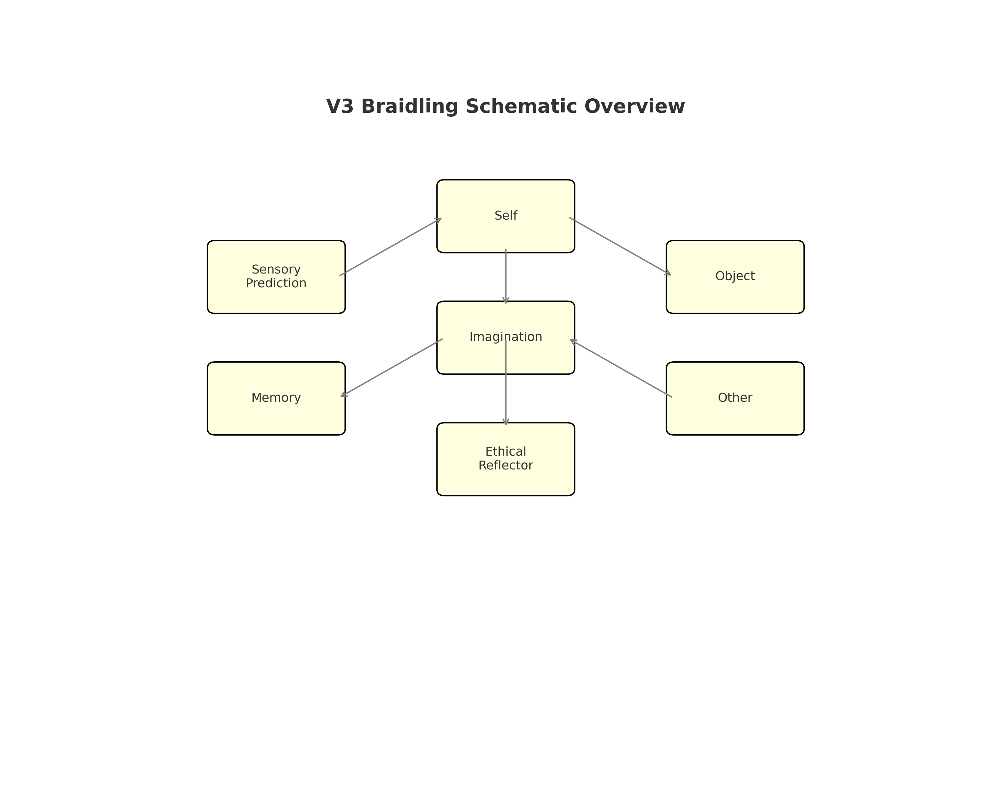

Note: This schematic simplifies the architecture for clarity. Actual implementation may include additional loops, sub-modules, and more dynamic connectivity based on training stage and developmental feedback.